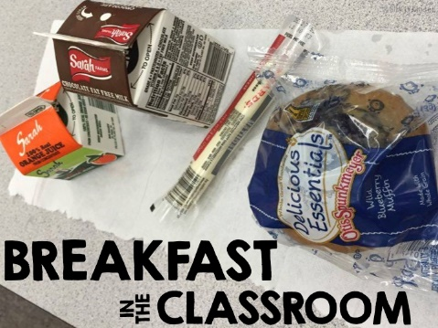
After the Bell (ATB) Breakfast in the
Classroom (BIC)
in Your District Name
Introduction
We know that children who are hungry cannot focus on learning. In our high poverty school communities, where we know students experience food insecurity at home, an ATB BIC program offers all students an improved opportunity to access a healthy breakfast. It stamps out morning hunger and levels the playing field for morning learning.
- Breakfast is prepared and packaged by school nutrition staff, and delivered to each classroom.
- BIC operates during the first 10-15 minutes of the school day while teachers take attendance, collect/review homework, assign a “do now,” or teach a short lesson plan.
- When they enter their classrooms, student help themselves to a free breakfast of nutritionally well-balanced foods like fresh fruits, milk, juice, yogurt, and whole grains.
- When students are done eating, they clean up after themselves.
- Leftover food is returned to the cafeteria and shelf-stable items are placed in the classroom share bin.

Teacher Role
- Create a morning routine for BIC in your classroom.
- Encourage students to participate in breakfast to fuel morning learning. Example:
“Breakfast helps fuel morning learning. I encourage you to take a breakfast. Anything shelf-stable can be put in the share bin for access later. If you are not hungry or do not want breakfast, you do not have to take it.”
- As you take attendance, check off those students that take breakfast (see page 2).
- Delegate age-appropriate tasks for students, i.e., pick up insulated bags from the cafeteria & deliver them to the classroom, return bags to the cafeteria, dispose of trash and wipe down tables, etc.
- Ask cafeteria or custodial staff if you need more food or clean-up supplies.
- Leave instructions for substitute teachers who are new to BIC.

Benefits Include
- Improved morning focus and academic performance. In one study, math scores improved by 17.5%.
- Fewer morning disturbances and visits to the school nurse for headaches/stomachaches. Schools in Taunton and Springfield report 23-24% reduction in morning nurse visits, correlating to ~18,000 minutes of learning time.
- Attendance and tardiness rates improve.
- BIC time allows for unstructured relationship building between teachers/students & students/students. This social-emotional time builds classroom relationships that strengthen learning.
When students EAT TOGETHER, they LEARN about each other.
When students KNOW EACH OTHER better, they WORK TOGETHER better.
When they WORK TOGETHER better, they ACHIEVE TOGETHER better.

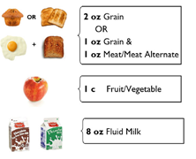
Meal Accountability
Students must take three components:
- Main menu offering
- At least one fruit serving—either juice or fruit (or both!)
- Milk is optional
- Shelf-stable food students don’t want to eat can go in the share bin, perishable food must be returned to the cafeteria or thrown out.
→ Our school packages the reimbursable components. Students must take this packaged bag to have the meal count. The milk and additional fruit are optional.
Record Keeping by Teachers
Participation Rosters
To properly claim USDA reimbursement for BIC meals, it is important to accurately document participation.
- Every student is marked with either a to indicate participation or to show they did not participate. Students who are absent from breakfast should be marked with an “A” on the breakfast roster.
- Please sign the roster at the end of the week, and initial daily, to indicate you have overseen the process and believe it to be accurate.
- Send completed rosters back to the Cafeteria daily in BIC totes [along with your lunch orders]! Rosters will be back in the totes the following morning.
Thank you!!!
Sample Completed Roster
Grade | First Name | Last  Name | Monday | Tuesday | Wednesday | Thursday | Friday
K | Liz | Cote
K | Laura | Green
K | Michael | Moore |  |  |  | A | A
K | Alex | Roberts |  | A
K | Sam | Sullivan
K | Mary | Throwe |  |  |  |  | A
Totals |  |  | 6 | 4 | 5 | 5 | 3
Teacher initials daily
Teacher Signature (at end of week): ____________________________________________________

